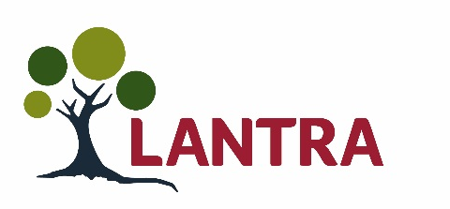
Awards for Land–based and Aquaculture Skills 2020
Secondary school nomination form
Land-based, environmental and aquaculture industries are incredibly important to Scotland for a whole range of reasons: quality of life; high quality food; timber; health and welfare of animals; leisure activities; well-being; enriching the rural environment and urban green space and protecting our natural heritage.
Lantra Scotland’s ALBAS (Awards for Land-based and Aquaculture Skills) recognise the achievements of schools and partners in these areas.
Our Secondary School Awards are sponsored by RHASS and celebrate school projects and activities which support and encourage increased knowledge and understanding in rural learning.
If you’d like to enter your school, please read the following guidance and then fill out the form. If your work is in partnership with other organisations, please complete our Partnership Working form.
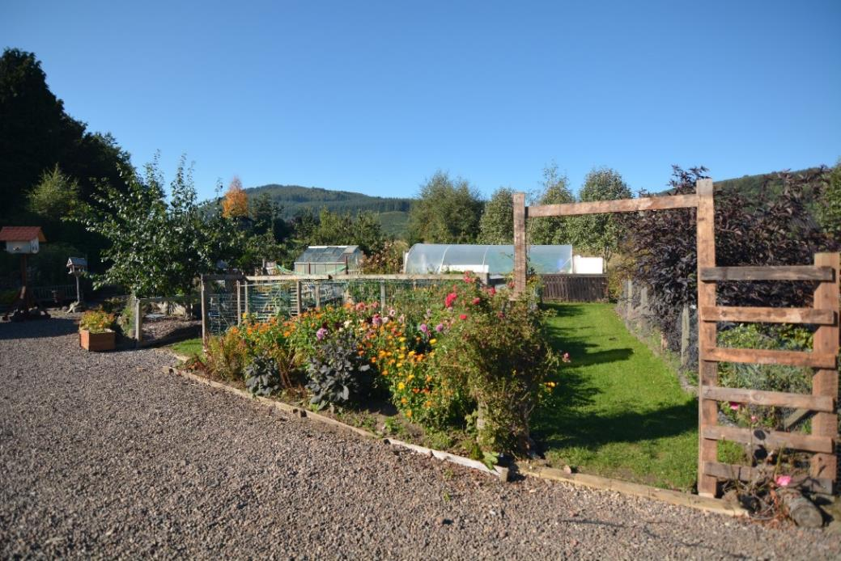
A school garden maintained for the benefit of pupils and the wider community.

How to make a nomination
We are looking for schools which have been involved in projects along the lines of: a school garden or vegetable plot; a biodiversity project or a community woodland; delivering rural skills as part of the curriculum or with a local farmer or crofter. The activity should have been running at any point between September 2018 and September 2019.
To make a nomination, just complete this form and tell us how your project or activity has benefited pupils, the school and the wider community, explaining why your school deserves to win an award. Please submit photographs and logos as high-resolution jpegs to support your nomination. Short videos would be helpful too.
Please send your completed forms to scotland@lantra.co.uk or post them to Lantra Scotland, Inveralmond Business Centre, Auld Bond Road, Perth PH1 3FX by Friday 15th November 2019
After an independent panel of judges reviews all the entries, finalists and guests are then invited to a fabulous awards ceremony at the DoubleTree by Hilton Dunblane Hydro on the evening of Thursday 5th March 2020.
Nominated secondary school details
School name:
School address and postcode:
School website:
Contact name within school:
Contact job title:
Contact daytime telephone number:
Contact mobile number:
Contact email:
Q1 Give a brief outline of the project or activity and how it was delivered (up to 100 words).
Q2 What were the school’s objectives for choosing this project or activity and what did it expect to achieve (up to 100 words)?

Q3 What have the pupils gained from the experience of the project or activity (up to 100 words)?
Q4 How has the project or activity benefited the school and the wider community (up to 100 words)?
Q5 What plans does the school have to extend the project or activity and what will be its legacy (up to 100 words)?
Q6 Please outline any positive environmental impact that the project or activity has produced (up to 100 words).
Q7 How many pupils were involved in the project or activity in your school?
Q8 Of the pupils involved in the project or activity, how many have gone onto the following?
Still in Secondary School: |  | Further Education:
Higher Education: |  | Modern Apprenticeship:
Employment in a land-based industry: |  | Employment in a non land-based industry:
Q9 How would your school use the prize money?

Q10 Tell us about any other land-based and aquaculture project or activities carried out by your school.

Q11 Does your school deliver Skills for Work (Rural Skills) or National Progression Awards in
Rural Skills or Aquaculture? If yes, please tell us more below:
If no, would you like more information about these programmes?
 | ☐ | Yes | ☐ | No
Q12 Where did you hear about our Awards for Land-based and Aquaculture Skills?
Please tick relevant box.
 | ☐ | Lantra website |  | ☐ | Media (please state):
 | ☐ | Social media |  | ☐ | Lantra e-newsletter
 | ☐ | Other (please state):

Why should you win this award?
Please tell us why your school deserves to win this award (in up to 300 words).

Photographs and videos
Please supply a range of high resolution JPEG images and a copy of the school logo (if you have one). Short videos of the project in action would be helpful too. These will be used as part of your application. We may use your photographs at the award ceremony and in PR for the event.
Data protection
Lantra gathers and processes your personal information securely in accordance with our privacy policy and in compliance with the relevant General Data Protection Regulation (GDPR) and laws. We may retain and use the details and images you provide with this form in generating positive publicity for our awards online and in printed media for up to two years. Your application will be passed to the team of independent judges and not shared with anyone else. If you are not selected as a finalist in our awards, we will delete the data you have sent us. Visit www.scotland.lantra.co.uk/privacy-policy to find out how we process your data.
Please tick this box and complete the following section to show you agree.
Name (please print)
Signature
Date
Please tick here to confirm you have permission from parents or guardians of any under 16s in any images or videos you share with us.
Please tick if you have supplied us with images.
Please list relevant local newspapers, radio stations, professional journals or online media for your area or industry.
Social media: we would like to tag your school and partners, so please provide us with usernames
Name of Head Teacher (please print)
Signature of Head Teacher
Date

About Lantra Scotland
Lantra in Scotland supports our land-based, aquaculture and environmental conservation industries in developing highly skilled workforces capable of competing in today’s local and global economy. We work to raise the attractiveness of our sector to new entrants, as they will be the workforce of the future.
We aim to ensure that potential school leavers, graduates and career changers see the land-based and aquaculture sectors as attractive career choices. Our work ensures that they, their careers advisors and parents are aware of the exciting opportunities for rewarding careers within these areas.
To find out more about training or careers in our sectors, please call Lantra Scotland on 01738 310164, or email scotland@lantra.co.uk

School awards sponsored by RHASS
The Royal Highland and Agricultural Society of Scotland is for everyone who supports the very best standards in agriculture, forestry and stewardship of the countryside, which are an essential part of our heritage – and our future. Industries in our rural areas are major contributors to the economy and character of the country. We are delighted to play a small part in encouraging our schoolchildren to get involved in projects that develop rural skills.

Lantra Scotland is supported by the Scottish Government

6 Sep 2019 • #ALBAS20 • Registered no: 2823181 • Charity no: 1022991 • Scottish charity no: SC039039

