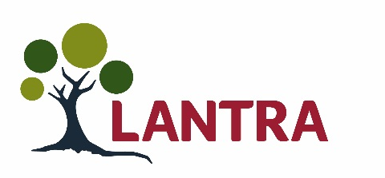
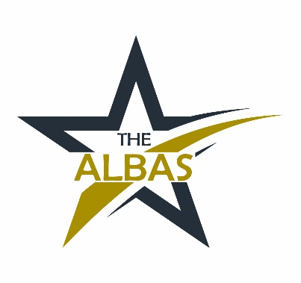

Awards for Land-based and Aquaculture Skills 2022

Partnership Working nomination form
Land-based, environmental and aquaculture industries are incredibly important to Scotland for a whole range of reasons: quality of life; high quality food; timber; health and welfare of animals; leisure activities; well-being; enriching the rural environment and urban green space and protecting our natural heritage.
Lantra Scotland’s ALBAS (Awards for Land-Based and Aquaculture Skills) recognise the achievements of individuals, employer partnerships and training providers in these areas. They also raise the profile of training and employment opportunities, highlighting the benefits to employers of a well-trained and highly skilled workforce.
As a society, we depend heavily on our natural resources. We recognise their importance and the complexities involved in their management. Lantra believes effective partnership working is a vital part of ensuring we gain maximum benefit from limited resources, whether that be in promoting new initiatives, attracting new entrants or developing the skills of managers.
The Anna Murray Partnership Working Award is a celebration of collaborative projects and activities which support and encourage increased knowledge and understanding in the land-based and aquaculture sector. As well as the prestige and public recognition from our high profile awards ceremony on Thursday 3rd March, winners will also receive a prize of £250 (to be shared collaboratively).
It is dedicated to the memory of our colleague Anna Murray from the Scottish Government, who strongly believed that when people work together, anything is possible.
If you’d like to enter our awards, please read the following guidance and then fill out our form, identifying the lead partner and the other partner organisations involved.

How to make a nomination
To be eligible, you and your partners could be: developing materials or resources for schools; working on a biodiversity project or in a community woodland; delivering rural skills as part of the curriculum or working in partnership with a group of others on a training or skills initiative.
The work must have been taking place at some point between September 2020 and September 2021.
To make a nomination, just complete this form and tell us how your project or activity has benefited those in the group as well as others in the wider community or sector. Please include photographs and logos as high-resolution jpegs.
Please send your completed forms to scotland@lantra.co.uk or post them to Lantra Scotland, Inveralmond Business Centre, Auld Bond Road, Perth PH1 3FX by Friday 3rd December.
An independent panel of employers and industry representatives judge all the entries before interviewing the short-listed nominees. Then on Thursday 3rd March, winners will be announced at our high profile awards ceremony.
Nomination details (Lead partner)
Organisation name
Address and postcode
Website
Contact name
Contact job title
Contact daytime telephone number
Contact mobile number
Contact email
Q1 Provide a brief outline of the project or activity and how it was delivered (in up to 50 words).
Q2 What were the group’s objectives for choosing this project or activity and what did it expect to achieve (in up to 50 words)?

Q3 What have those involved gained from the experience of the project or activity (in up to 50 words)?
Q4 How has the project or activity benefited the group as well as the wider community/sector (in up to 50 words)?
Q5 What plans does the group have to extend the project or activity and what is its legacy (in up to 50 words)?
Q6 Please outline any positive environmental impact that the project or activity has produced (in up to 50 words).
Q7 How many individuals were involved in the project or activity?
Q8 How would your group use the prize money?

Q9 Tell us about any other land-based and aquaculture project or activities carried out by your partnership.

Q12 Where did you hear about our Awards for Land-based and Aquaculture Skills?
Please tick relevant box.
 | ☐ | Lantra website |  | ☐ | Media (please state)
 | ☐ | Social media |  | ☐ | Lantra e-newsletter
 | ☐ | Other (please state)

Partner 1
Please tick the category which describes your organisation best.
☐ | Land-based/aquaculture employer | ☐ |  | Training provider | ☐ | College |  | ☐ | Teacher
☐ | University |  | ☐ Other
Please provide your name, address and contact details.
Partner name
Partner address
and postcode
Contact name
Contact job title |  | Contact telephone
Contact mobile number |  | Contact email

Partner 2
Please tick the category which describes your organisation best.
☐ | Land-based/aquaculture employer | ☐ |  | Training provider | ☐ | College |  | ☐ | Teacher
☐ | University |  | ☐ Other
Please provide your name, address and contact details.
Partner name
Partner address
and postcode
Contact name
Contact job title |  | Contact telephone
Contact mobile number |  | Contact email

Partner 3
Please tick the category which describes your organisation best.
☐ | Land-based/aquaculture employer | ☐ |  | Training provider | ☐ | College |  | ☐ | Teacher
☐ | University |  | ☐ Other
Please provide your name, address and contact details.
Partner name
Partner address
and postcode
Contact name
Contact job title |  | Contact telephone
Contact mobile number |  | Contact email

Partner 4
Please tick the category which describes your organisation best.
☐ | Land-based/aquaculture employer | ☐ |  | Training provider | ☐ | College |  | ☐ | Teacher
☐ | University |  | ☐ Other
Please provide your name, address and contact details.
Partner name
Partner address
and postcode
Contact name
Contact job title |  | Contact telephone
Contact mobile number |  | Contact email

Partner 5
Please tick the category which describes your organisation best.
☐ | Land-based/aquaculture employer | ☐ |  | Training provider | ☐ | College |  | ☐ | Teacher
☐ | University |  | ☐ Other
Please provide your name, address and contact details.
Partner name
Partner address
and postcode
Contact name
Contact job title |  | Contact telephone
Contact mobile number |  | Contact email

Supporting statement
Please tell us why your partnership deserves to win this award (in up to 300 words).

Any questions?
To find out more, just call us on 01738 310164 or email scotland@lantra.co.uk

Photographs and videos
Please supply a range of high resolution JPEG images and a copy of the school logo (if you have one). Short videos of the project in action would be helpful too. These will be used as part of your application. We may use your photographs on our social media and PR for the event.
Data protection
Lantra gathers and processes your personal information securely in accordance with our privacy policy and in compliance with the relevant General Data Protection Regulation (GDPR) and laws. We may retain and use the details and images you provide with this form in generating positive publicity for our awards online and in printed media for up to two years. Your application will be passed to the team of independent judges and not shared with anyone else. If you are not selected as a finalist in our awards, we will delete the data you have sent us. Visit www.scotland.lantra.co.uk/privacy-policy to find out how we process your data.
Please tick this box and complete the following section to show you agree.
Please ensure you have permission from parents or guardians of any under 16s in your images before completing the following form.
Name of lead partner (please print)
Signature
Date
Please tick here to confirm you have permission from parents or guardians of any under 16s in any images or videos you share with us.
Please tick if you have supplied images | ☐
Please list relevant local newspapers, radio stations, professional journals or online media for your area.

About Lantra Scotland
Lantra in Scotland supports our land-based, aquaculture and environmental conservation industries in developing highly skilled workforces capable of competing in today’s local and global economy. We work to raise the attractiveness of our sector to new entrants, as they will be the workforce of the future.
We aim to ensure that potential school leavers, graduates and career changers see the land-based and aquaculture sectors as attractive career choices. Our work ensures that they, their careers advisors and parents are aware of the exciting opportunities for rewarding careers within these areas.
To find out more about training or careers in our sectors, please call Lantra Scotland on 01738 310164, or email scotland@lantra.co.uk
Lantra Scotland is supported by the Scottish Government

24 September 2021 • #ALBAS22 • Registered no: 2823181 • Charity no: 1022991 • Scottish charity no: SC039039

